**Expemant 1: To show unconscious ensemble processing**

Procedure for each trial :

show ensumble faces (1 sec)

delay (1 sec)

show test face (100ms)

make judgement of the emotion on test faces (from -10 ~ 10)

report visiblility of each faces (2up1down, stepsize = 0.02)

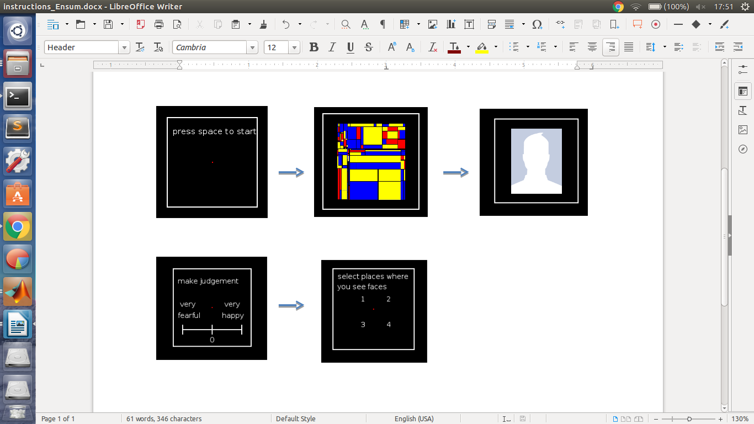

ensumble condition : fully emotional faces are used

(1) 4 negative 0 potitive

(2) 3 negative 1 potitive

(3) 2 negative 2 potitive

(4) 1 negative 3 potitive

(5) 0 negative 4 potitive

test faces:7 faces range from fully negative, neutral to fully positive.

Variation : faces from two person (A,B) is used

(1) A for ensumble; B for testing

(2) B for unsumble; A for testing

In total will be ensumble 5* testface 7* variation 2* repeat 10 = 350 trials

**Experimnet 2: To show how unconscious individual elements influence ensemble processing**

Procedure for each trial :

show ensumble faces (1 sec)

delay (0.5 sec)

make judgement of the average enmotion (from -10 ~ 10)

report visiblility of each faces

ensemble condition : 9 condition

conscious faces

(1) 3 negative 1 potitive (average of the negetive faces -25, positive take 25)

(2) 2 negative 2 potitive (let the overall average be 0)

(3) 1 negative 3 potitive (average of the positive faces 25, negative take -25)

unconscious faces : fully emosional faces are used

(1) 2 negative 0 potitive

(2) 1 negative 1 potitive

(3) 0 negative 2 potitive

